† Information in this document has been adapted from the Intersectionality Guide and Intersectionality Reflection Workbook available from https://knowledgetranslation.net/portfolios/intersectionality-and-kt/

What does taking an equity, diversity and inclusion lens mean?
Taking an equity, diversity and inclusion lens means looking at the world in a way to recognize that people’s experiences are shaped by a combination of social factors, such as gender, race, physical traits and abilities, age, among others. These interconnected social factors create unique experiences of power, privilege, discrimination and oppression, and we must consider everything that can create an imbalance or disadvantage. Some refer to this approach as intersectionality.,,

What are intersecting categories?
Intersecting categories include age, gender identity, sex, physical ability, and other aspects of one’s lived experience. These aspects interact to form a person’s identity (see figure below). An individual’s intersecting identity reflects larger systems of oppression and privilege. An individual’s social identity shapes their experiences in the world and how they view it, including conscious and unconscious biases they hold.

Why take this approach in research?  - It provides a framework to be inclusive and to consider the unique experiences of the individuals on your research team.  - It helps to recognize the importance of individuals’ social identities within the greater context of systems and structures of power that reflect macro systems of privilege and oppression.  - Keep in mind that recognizing areas of advantage, disadvantage, and oppression may bring up feelings of confusion, guilt, distress, among others.  - It is okay to feel uncomfortable because this is a brave exercise. There is a difference between feeling uncomfortable and feeling unsafe. | 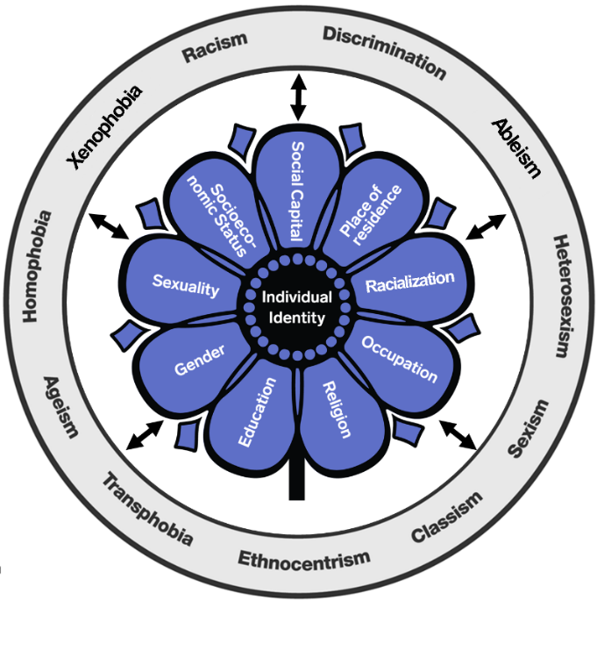  A visual depiction of how intersecting categories can shape one’s individual identity (not exhaustive).

Consider your own diversity

What is the purpose of the activity?
To help individuals explore areas where they experience advantages and/or disadvantages in their lives.

Instructions
Use the wheel diagram (below) to explore areas where you have experienced advantage or disadvantage in your life.
- Circle the factors that bring you ADVANTAGE.
Advantage is a special right or privilege available to a particular person or group of people. It can be earned or unearned.
- Underline the factors that bring you DISADVANTAGE.
Disadvantage is when a special right or advantage is unavailable to a particular person or group.
- In some cases it may be both!
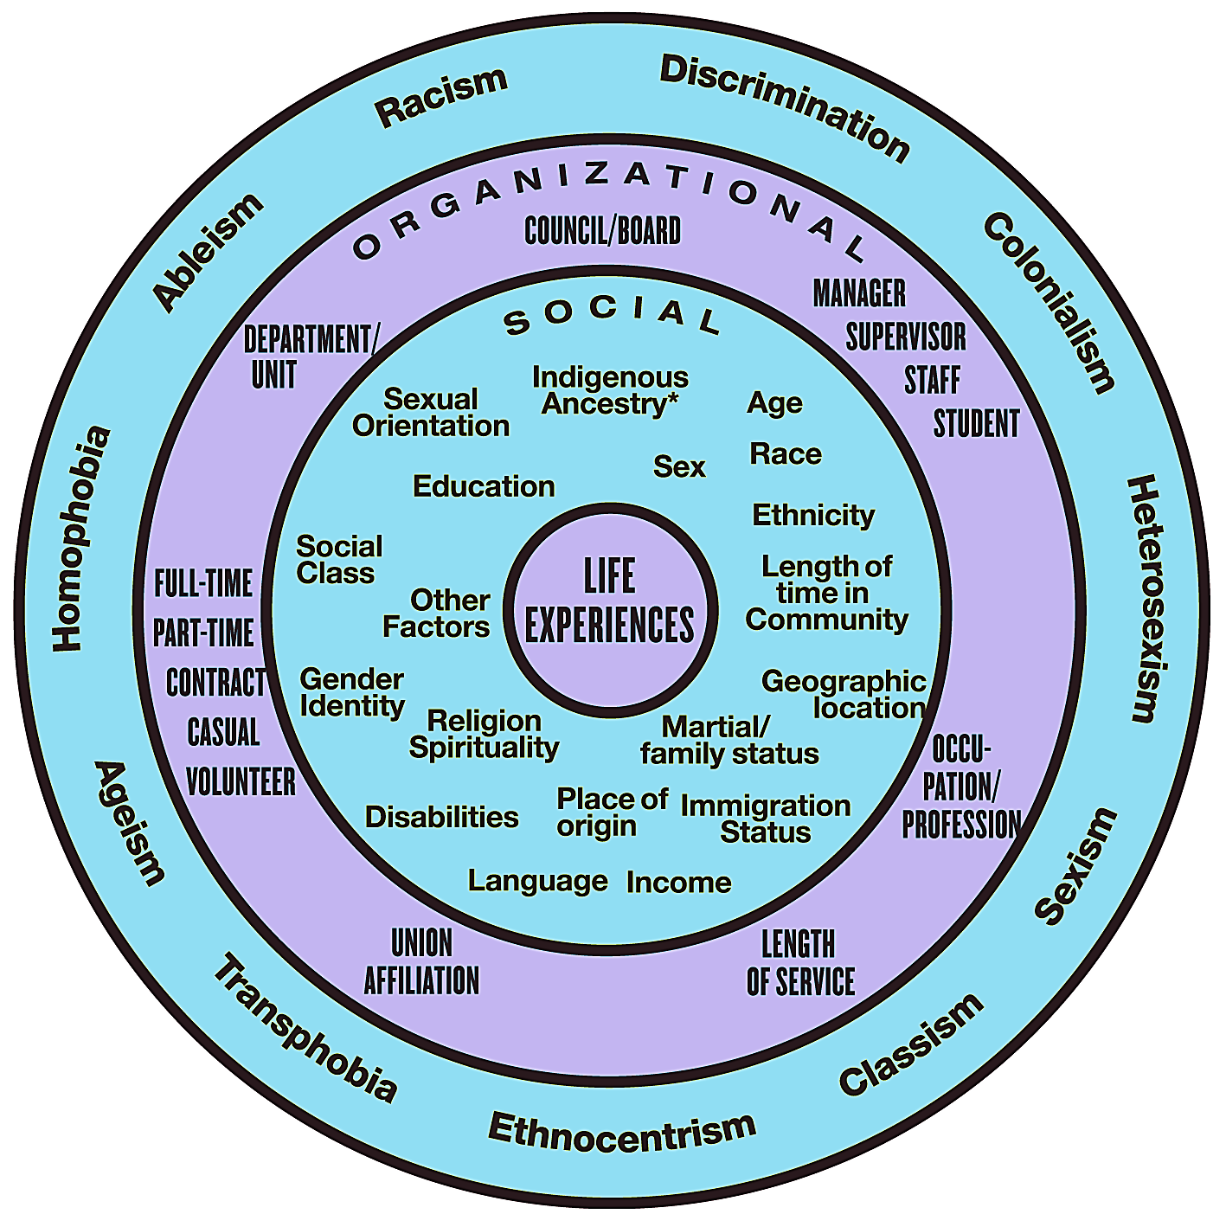
The inner circle contains social factors that influence the extent to which we experience advantages or disadvantages in our lives. It is the intersection of these factors that influences the way we experience life in our society. These factors include sexual orientation, Indigenous ancestry, age, social class, education, sex, race and ethnicity, length of time in the community, gender identity, religion and spirituality, place of origin, marital or family status, geographical location, disabilities, language, income, immigration status, and other factors.
The middle circle contains positions or statuses we may fill within the team or organization that carry varying amounts of power and influence. It is often the intersection of these positions, statuses, and social factors that determine our opportunities. These might include being a manager/ supervisor/staff member/student; type of occupation/ profession; length of service; union affiliation; department/ unit; and whether we are full-time/part-time/contract/casual/volunteer employee.
The outer circle contains the ways in which people are discriminated against. Most of us experience more than one form of discrimination. These factors interact with wider social forces, such as history and the legacies of colonialism, patriarchy, economic exploitation, level of education, inaccessible legal systems, and racist immigration policies. Some forms of discrimination include ableism, racism, heterosexism, sexism, classism, ethnocentrism, transphobia, ageism, and homophobia.

Reflecting on your intersecting categories and social identities when starting your project

Where am I situated?
☐ Reflecting on your responses to the above activity, what intersecting categories make up your identity?
☐ How do your intersecting categories impact your place in society?4
☐ How do your identities relate to the project’s topic area? How might your place in society impact your work on this project?4

Who is on the project team?
Consider including voices that reflect a range of intersecting categories.
☐ What does an inclusive approach mean to you?
☐ What inclusive approaches have been used in your team?
☐ What are the real and perceived power differences on the team?
☐ Reflect on whether everyone who could be on the team has been asked if and how they would like to be involved. Think about how different perspectives that represent a range of intersecting categories have been examined.
☐ Does your team reflect the makeup of the patient, community, and health care providers affected by the project topic?
☐ Who is the patient, healthcare provider, and community affected by the project topic area? What would they want to get out of the project? How do you plan to get them involved?

Tips
- Include multiple individuals to represent a particular group (e.g., include at least two patient partners instead of one).
- Provide a range of supports (e.g., training, easy to understand information).
- Create space for informal social interaction (e.g., build relationships among team members).
- Watch this 3-minute video (https://www.youtube.com/watch?v=PYaK1WphTuk) on unconscious bias.

What is the problem?
Problems are discrepancies between the current state and a desired state. For example, a desired state could be to have every patient receive quality and timely care, while the current state could include long hospital wait times and crowding where patient care is delivered in hospital hallways.
☐ Whose point of view is reflected in this research? For example, is it a funding agency, a policy-maker, or a patient group who identified and prioritized the problem to be studied? Consider who may gain and who may lose if the problem is addressed.
☐ What are the information gaps in the problem area? How can these gaps be filled? Information gaps are areas where you do have complete knowledge.

Tips
- Speak with those who have lived experience with the project topic (e.g., patients) and those who work in it (e.g., providers).
- Consider if information gaps are similar for different demographic groups. Do people of different ethnicities experience the problem at similar rates? Is there information regarding some intersecting categories but not others?

Appraising the evidence
Evaluate the quality of data included and being used in the project.
☐ What information do you have? What information do you wish you had? Who might have this information? Who should you talk to about this?

Tips
- Relevant evidence includes published evidence and the experience of those living and interacting with the problem, the evidence-to-practice gap, and the practice change.
- Be sure to evaluate lived-experience research, grey literature, and commentaries in addition to evidence syntheses.

Reporting on the evidence
Part of taking an equity, diversity and inclusion lens is being aware of the language we are using.
☐ Who will read this report? Keep the target audience in mind when writing the report.
☐ Whose point of view is reflected in the report? Consider who may gain from the findings and who may lose.
☐ Is the information presented in a balanced and unbiased way using standardized reporting checklist?

Tips
- Use people first language as opposed to labels that add to stereotypes.
  - Youth Mental Health Canada. People First Language. https://ymhc.ngo/resources/people-first-language/
  - 519 Glossary of Terms. https://www.the519.org/education-training/glossary
- Use plain language whenever possible.
  - Plain Language Thesaurus for Health Communications. www.cdc.gov/other/pdf/everydaywordsforpublichealthcommunication.pdf
- Use the active voice.
  - Active voice. https://www.plainlanguage.gov/resources/articles/dash-writing-tips/
†For more guidance on taking an equity, diversity and inclusion lens to your research, please visit https://knowledgetranslation.net/portfolios/intersectionality-and-kt/

Crenshaw Kimberlé. Mapping the Margins: Intersectionality, Identity, and Violence Against Women of Color. Stanford Law Review. 1991;43(6):1241–1300.
Carbado DW, Crenshaw KW, Mays VM, Tomlinson B. INTERSECTIONALITY: Mapping the Movements of a Theory. Du Bois Rev. 2013 Fall;10(2):303-312. doi: 10.1017/S1742058X13000349.
We are aware that there has been criticism regarding the history of the term intersectionality. Our intention is not to bring people further apart, but to bring people together and to celebrate the unique experiences and identities each of us hold.
Hankivsky O, Grace D, Hunting G, Giesbrecht M, Fridkin A, Rudrum S, Ferlatte O, Clark N. An intersectionality-based policy analysis framework: critical reflections on a methodology for advancing equity. Int J Equity Health. 2014 Dec 10;13:119. doi: 10.1186/s12939-014-0119-x.

